SMHA Executive Meeting
Date: June 9, 2020
Meeting in Session:
7:00 PM

Executive Members Present:
Lisa Chartrand | Steve Almas | Liz Minty | Andrew Hill
Andrew Rolston | Chris Becker | Annette Lewis | Shona Becker
Laurie Tutlaluk | Corinna Pounder
Mike Grutowski | Terry Rolston |  | Crystal Gove

Regrets:
Dave Piket

Motions
- To accept May 2020 minutes (Laurie, Steve, accepted unanimously)
- To accept the mission statement as presented and to replace the current association objectives (Crystal, Laurie, accepted unanimously)

Reports
- Treasurer Report – Liz
  - No new update

- Report – Registrar – Annette
  - No new update
Correspondence
- BC Hockey meeting Friday June 12th 12pm
- OMAHA – Steve Almas to correspondence with OMAHA with return to play committee

New Business
- Website, Facebook, Instagram (Lisa and Andrew H.)

- Awards season 2019/2020
  - Possibly outside in summer?
  - Separate team awards?

- Return to Play subcommittee (Steve A, Annette)
  - VIA sport works with districts and provincial sports and are setting the return to sports protocol
  - Sub-committee to make plan and submit it for approval
  - Will need Head and Assistant coaches in place by August to help and train in new protocols
    - No contact play until at least September
    - Need to put together a plan for when a team member presents with sickness
  - Sub-committee with several directions and precautions that SMHA must abide by for start of season
  - Coaches need to wear masks, players not within 6 feet of each other, rinks need signage and hand sanitizer
  - Move forward with planning for the most restrictive plan and as restrictions ease, we can alter our plan
  - Refer below to VIASport Phases
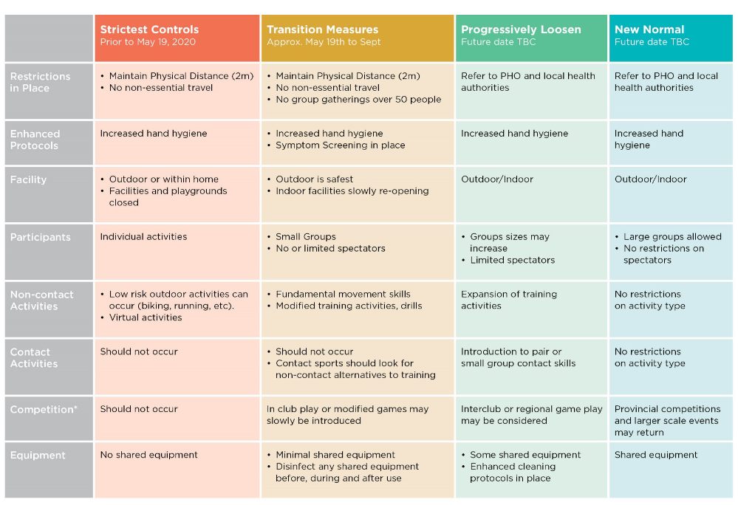

- SMHA Raffle
  - Decision to do raffle for 2020/2021 season postponed until August meeting

- SMHA Mission Statement and Objectives
  - Presented to executive
  - Whiteboards, signage, arena boards
  - Motion (see above)

- Registration (Annette)
  - Current costs for registration
    - $400 for youngest divisions
    - $460 for older divisions
  - Gaming grant pending (to hear by August)
  - $300 for registration (deposit)
    - with add on that fees will increase as games and ice time increases
    - offer on Team Snap payment plan
  - registration July 1st - August 10th

- Baseline Testing (Andrew H)
  - Can generate codes for players to complete baseline testing from home
  - Deadline for purchase July 18th (Andrew H to follow up with pricing)

- Parent Code of Conduct and Player Code of Conduct
  - Sub-committee to meet and update
  - Will email out for approval prior to July 1st

- Fall Rec Guide
  - Annette put together advertisement for district fall rec guide

- District of Summerland not opening rink until first week of September
  - SMHA submit for August 30th and 31st for summer ice
  - Ice allotments for rest of season submitted in September

Next Meeting: Tuesday, July 14, 2020 7pm

Adjourn: 8:10 pm (Andrew H, Chris)

