SMHA Team Managers Manual
The team manager is a central figure in creating the flow of communication not only within the team, but between the team and all support systems such as SMHA. Ultimately the manager is responsible for ensuring all the off-ice tasks are completed. This does not mean that the manager has to it all, he/she needs to make sure that it gets done via delegation. By taking on the operational aspects of the team, the manager enables the coaching staff to focus on player development and on-ice instruction to provide the players with a rewarding hockey experience.
Some websites that might help you with your role:
www.summerlandminorhockey.org www.omaha.ca www.bchockey.net www.hockeycanada.ca

LOTS MORE DOCUMENTS AVAILABLE!
- You will be contacted with a way to access more information
- If you have immediate questions, please contact the Executive member responsible for that question or your Divisional Director.
Divisional Directors 2022/23
Division | Name | Contact
U7 | Natalie Langlois | Natalie.fare.langlois@gmail.com
U9 | Crystal Gove | crystalgove@outlook.com
U11 | Chris Becker | beckerchris@shaw.ca
U13 | Alana Barker | cam.alana@gmail.com
U15 | Brad Dollevoet | brad.dollevoet@gmail.com
U18 | Jana Austen | janaausten@hotmail.com
Female Director | Corrina Pounder | summerlandicemanager@gmail.com
SMHA Executive 2022/2023
Role | Name | Email Contact
President | Crystal Gove | crystalgove@outlook.com
Vice-President | Brad Dollevoet | brad.dollevoet@gmail.com
Past President | Lisa Chartrand | chartrandlisa1@gmail.com
Registrar | Annette Lewis | annettelewis@shaw.ca
Treasurer | Liz Minty | myntti@telus.net
Secretary | Natalie Langlois | Natalie.fare.langlois@gmail.com
Ice Manager | Corrina Pounder | summerlandicemanager@gmail.com
Head Coach | Andrew Rolston | arolston@shaw.ca
Sr Director | Chris Becker | beckerchris@shaw.ca
Jr Director | Cam Barker | cam.alana@gmail.com
Referee In Chief | Patricia Gove | Patricia_Gove@hotmail.com
Risk Manager/Team First | Alana Barker | cam.alana@gmail.com
Tournament Coordinator | Jana Austen | janaausten@hotmail.com
Member at Large | Andrew Hill | hillaj17@gmail.com
Assistant Referee In Chief | Chris Becker | beckerchris@shaw.ca
Equipment Manager | Barry Hotson | barry.hotson@gmail.com
Fundraising Coordinator | Alison Smirle | asmirle@hotmail.com
Goalie Coach | Tyson Felt & Andrew Rolston (jr) | tysonfelt@gmail.com
GENERAL INFORMATION
SMHA Team Manager Responsibilities
September start up
- Attend coaches/managers meeting
- Manage SMHA office division mailbox (code HOCKEY)
- Email registrar with team official names, cell phone numbers, and emails
  - Head coach
  - Assistant coaches
  - On-ice helpers
  - Manager
  - Safety
- Have a team meeting with coach and parents to establish expectations for the year
- Obtain an official roster from registrar
- Find tournaments at www.bchockey.net
- Decide on team fees and open an account using team name and year
- Double check locker for jerseys
- Possible team volunteer roles:
  - Jersey parent (collect jerseys, bring jerseys to games, wash jerseys)
  - Treasurer (open and manager bank account, collect team fees)
  - Fundraiser (organize fundraising events, apply for gaming license)
  - Skate sharpener (take team skates for sharpening between practices)
  - Tournament coordinator (main contact for hosting divisional tourney)
  - Scorekeepers/Timekeepers (co-ordinate schedule for home games)
  - Media manager (put in stories and photos to Summerland Review)

During the Season
- inform Ice Manager and Referee In Chief of any schedule changes
- keep all receipts and expenses you may encore
- update OMAHA website with home scores and submit scoresheets to OMAHA
- act as a liaison between coach, players, parents
- ensure media write-ups are being done and team sponsor is included
- ensure jerseys are being cleaned
- collect bottle return receipts and hand in to Senior Director
End of season
- ensure all jerseys are accounted for and returned clean to team locker
- inform Equipment Manager of any missing or damaged jerseys
- send a thank-you note/card to team sponsor
- ensure any outstanding money has been paid to Treasurer
- complete year-end Financial Report and send to Treasurer

THINGS TO REMEMBER:
- If you are not using your ice time please let the ice manager know.
- Do not give away ice time without permission.
- If scheduled games have been cancelled please let the RIC know so that refs can be called and cancelled.
- December 1- all rep team officials need to be certified
- January 1-Financial report due (September-December)

Mandatory Team Staff (need to complete various courses)
- Head Coach
- Assistant Coach(es)
- Safety Person
- Manager
- On-Ice Volunteer (optional)

Other possible volunteers
- Treasurer
- Game Nutrition
- Jersey Care
- Timekeepers
- Score keepers (on tablet)
- Fundraising, such 50/50 tickets sellers, etc…
- Statistics sheets
- Tournament Chair/Committee
- Social/Event Committee
- Dryland coordinator

TEAM STAFF REQUIREMENTS
JUNIOR TEAMS (U7, U9, U11)
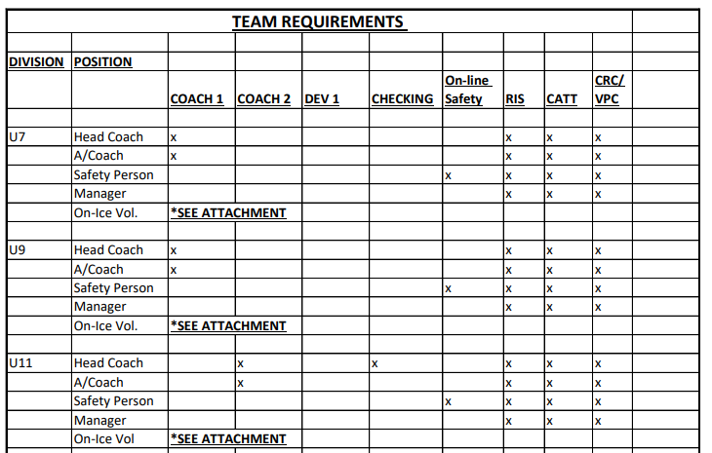

SENIOR TEAMS (U13, U15, U18)
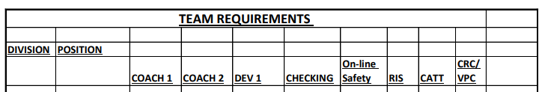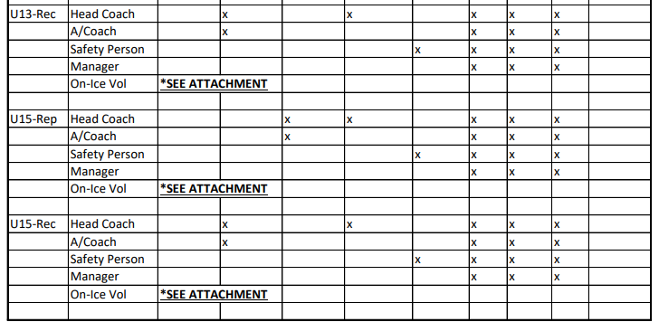
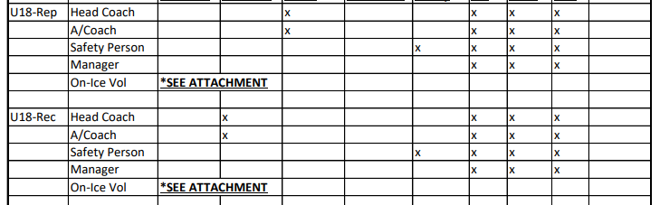
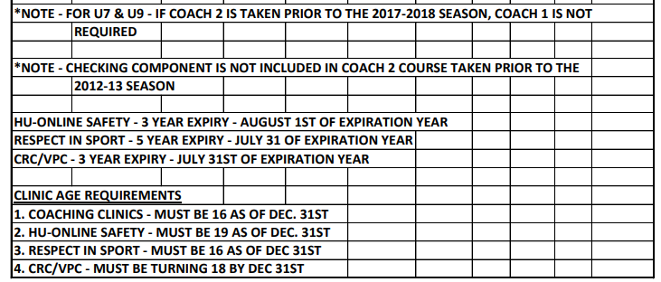
BC HOCKEY On-Ice Helper Qualification Chart
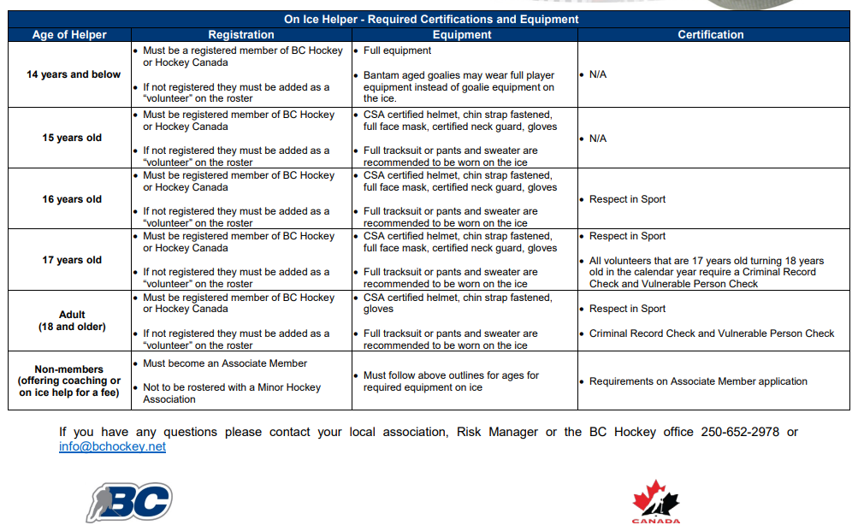
GAME DURATION (OMAHA)
- Use this to figure out warm-up, periods, ice cleans, time out
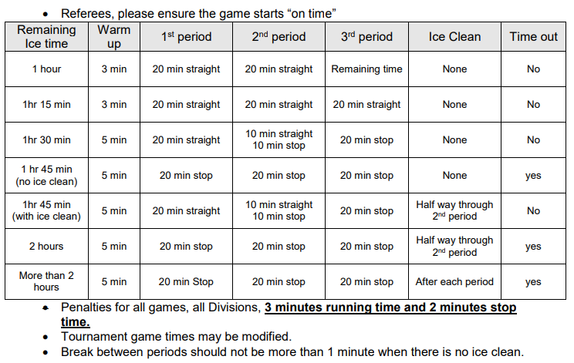

GAME CHECK LIST

PRE-GAME
- Ice booked
- Officials booed
- Volunteers line up & trained _________________________________
  - Game clock _________________________________
  - Score sheet _________________________________
  - Music _________________________________
  - 50/50 tickets _________________________________
  - Safety person _________________________________
  - Other: _________________________________
  - Other: _________________________________
- Dressing rooms checked & secure
Notes: ______________________________________________________________________________
__________________________________________________________________________________________

DURING GAME
- Monitor off-ice conduct of players & parents
- Check dressing rooms
- Check in with volunteers
Notes: ______________________________________________________________________________
__________________________________________________________________________________________

POST GAME
- Game report signed by officials & both teams
- Game sheet reported & sent in to OMAHA
Notes: ______________________________________________________________________________
__________________________________________________________________________________________

How To Apply for a Gaming License…
- Go to Online Service (gov.bc.ca)
- Click on Gaming
- Click on Class D License, scroll down and click on Step 3 online service
- Click Apply online
- Under search – type in %summerland%, scroll down and click new applicant
- Organization Name
  - Type current team name & year Summerland U15 #1 2021/2022
- Address
  - Use manager/fundraiser address
- Programs
  - Click Youth Sports, then click add
- Application Type
  - Check license
  - License Type – check class D
  - Event Type – check Ticket Raffle
  - Raffle Type – check percentage Draw
- Draw Percentage details 50/50
  - Tickets Details – start date: start of season end date: March 20, 2022
- Ticket Prices must be equal or less than $5000
  - 3 for $2 – 3000 tickets
  - 15 for $5 – 9000 tickets
- Draw Information
  - All 50/50 draws will be held at Summerland Arena, 8820 Jubilee Road. Home games are mainly held Saturday to Sunday between 7am – 9pm. Draws will be held at the 10 minute mark of the 3rd period
- Use of proceeds details
  - To help pay for tournament entry fees, extra costs of ice rental, officials, players development clinics
- Officers Responsible
  - One person is the contact, submitter and office responsible; two others are officer responsible. You will need addresses and phone numbers for these people.
- Fee
  - There is a $10 fee for the license, payable by credit card

BC HOCKEY INTERDISTRICT TRAVEL Form
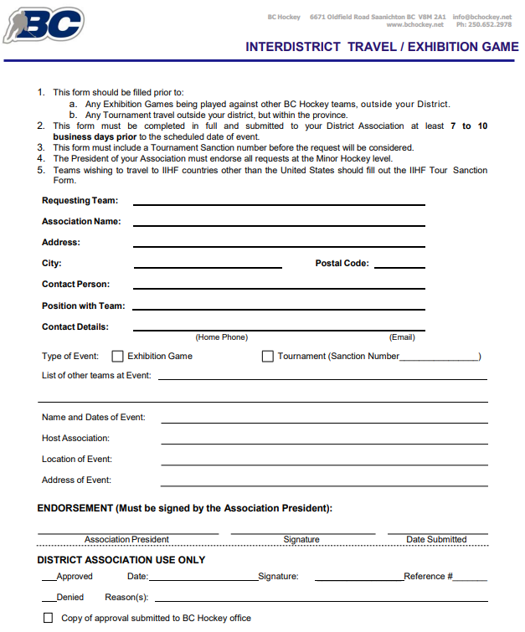
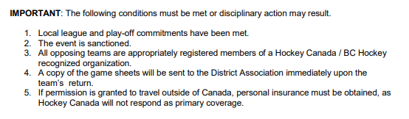
VARIOUS Portions from SMHA Policy & Guidelines
https://www.summerlandminorhockey.org/policies-guidelines/
SMHA Application for Fundraising
Date: ____________________________
Team: _________________________________
Contact Name: ____________________________________
Contact Email: ______________________________________________ Cell Phone #: ____________________________

Date of Fundraiser: ________________________________________________
Location of Fundraiser: ________________________________________________________

Company/fundraising idea | What will the players be doing/selling? | How will they be representing SMHA?

Please provide the direction of what your team will be using the funds for and any additional information relevant to this application: __________________________________________________________________________________________________
__________________________________________________________________________________________________
__________________________________________________________________________________________________
__________________________________________________________________________________________________
__________________________________________________________________________________________________
__________________________________________________________________________________________________
__________________________________________________________________________________________________
If the money is not spent on what was first applied for, then permission from the Executive must be granted first to change the direction of funds.
Approved by: ______________________________________________________ Date: ___________________________
Taken from SMHA Policy & Guidelines document (Oct 2018)
or online at https://www.summerlandminorhockey.org/policies-guidelines/
SMHA TEAM FINANCIAL REPORTING
1. SMHA is a non-profit organization under the British Columbia Societies Act and is staffed by volunteers. Although we pay our referees, NO member of the Association or participant may receive a personal benefit, cash or otherwise, without the written consent of the Executive.
2. The best way to protect personal integrity is to always operate in an open and well-documented manner.
3. All organizers, team managers and coaches associated in any way with minor hockey activities should follow uniform procedures for the control of all cash revenues and collections. It is therefore expected that:
A. The team manager will be responsible for providing parents and the Vice-President with a Financial Season End report (sample forms available from the Treasurer);
B. Interim financial reports may be requested by the Vice-President or the Treasurer at any time and are to be provided within seven days;
C. Team bank accounts should be opened, in the name of the team (with the permission of the President or the Vice-President). These accounts will provide monthly statements and return cheques;
D. All funds, statements and cancelled cheques as well as receipts, invoices and other financial records are to be kept safely and be made available upon request by the Vice-President or the Treasurer;
E. The account must have two signing officers for all cheques, one of whom is the team manager. The other is to be a team parent;
F. Either a receipt or an initialed team list should evidence all CASH transactions;
G. Excess funds in the team account at season’s end must be turned over to the Treasurer to be deposited in the S.M.H.A. Benevolent Fund; and
H. Under NO circumstances may excess funds be used in ways contrary to the fundraising policy.
Taken from SMHA Policy & Guidelines document (Oct 2018)
or online at https://www.summerlandminorhockey.org/policies-guidelines/

SMHA TEAM FUNDRAISING & Non-Parent Coach Policy
- All teams and participants have a responsibility to project a positive image of their team and the Association. At all times the public image, conduct and appearance of the SMHA membership must be above reproach.
- From time to time, parents and players will be expected to make direct contributions to meet team and Association expenses through fundraising efforts. The following guidelines are to be used:
  - ALL team fundraising activities and dates MUST be approved by the Vice-President PRIOR to commencing the activity. We live in a small community that will only tolerate so many activities on a weekend!
  - Teams requiring additional funds must outline a season budget and proposed fundraising activities.
    - The budget must be approved by a majority of the team parents present at a parent meeting.
    - The team head coach will ensure that a copy of the budget is given to the Vice-President.
    - The budget can be amended as needs arise but still require a majority of parents to approve.
    - Amendments must also be given to the Vice-President.
  - Teams may select from one or both of the following options to gather additional funds:
    - Direct financial contribution to the team by parents; and/or
    - Engage in fundraising activities.
  - All funds raised by fundraising are deemed to belong to the team.
    - If a player leaves the team he/she forfeits all monies raised to date.
    - At no time shall fundraising funds be returned to a player or a parent.
  - At the end of the season, all leftover funds shall be returned to the SMHA Treasurer to be deposited into the Benevolent Fund (used to help players in financial difficulty).
  - Teams may plan, budget and fundraise for the following purposes only (these items are for the benefit of the entire team and therefore it is appropriate to solicit for community donations):
    - Tournament registration fees;
    - Team hockey socks, one home and one away set;
    - The cost of motel/hotel accommodation for coaching staff at an away game or tournament, if the coach is not also a parent on the team;
      - Team will pay one room per entire staff at the motel/hotel the team is attending;
    - The cost of travel for coaching staff at an away game or tournament, if the coach is not also a parent on the team;
      - Maximum allowance is $0.40 per kilometer.
    - The cost of a daily meal allowance of $38.00 per day for a maximum of five team officials, all of which must be non-parent volunteers, for out of town games only.
      - Out of town games include tournaments, overnight trips, and daily out of town games. This allowance includes the following rules:
      - The per meal breakdown is as follows:
        - Breakfast - $10.00 per day;
        - Lunch - $10.00 per day;
        - Dinner - $18.00 per day; and
        - Total: $38.00 per day.
      - Should the out of town games include less than three meals, the $38.00 formula shall be amended (i.e. Lunch only for $10.00);
      - Should, in the case of an overnight stay, the hotel of choice include a meal in price of stay (i.e. continental breakfast) the $38.00 formula will be amended to exclude breakfast
        - The daily allowance shall now be $28.00 per coach; and
      - Claiming these non-$38.00 meal days is up to the discretion of coaches/team officials.
    - Additional Ice time (Approved by the Ice Manager in advance);
    - Costs for season-end banquet; and/or
    - Bus transportation to away tournaments.
  - UNDER NO CIRCUMSTANCES can teams solicit for donations from community businesses for personal use items such as the following:
    - Team jackets, track suits, hats, or other apparel (Exception is team socks);
    - Any personal hockey equipment;
    - Team meals other than season-end banquet;
    - Coach Manager thank you gifts;
    - Team or individual photographs;
    - Team or individual travel expenses other than the aforementioned coach’s expenses and bus costs;
    - Tickets to sporting events or other entertainment;
    - Sweater name bars; and
    - These items must be purchased by the players/families on an individual and personal option basis.
  - Fundraising activities can include candy sales, car washes, bottle drives, hot dog sales, 50/50 draws etc. as long as they are in good taste, well supervised and controlled.
    - Alcoholic beverages may not be used as prizes.
  - Fundraising activities should be carried out, chiefly, within our Association boundaries.
From time to time, parents and players will be expected to make direct contributions to meet team and Association expenses through fundraising efforts. (Dec. 13/16)
Taken from SMHA Policy & Guidelines document (Oct 2018)
or online at https://www.summerlandminorhockey.org/policies-guidelines/
SMHA Locker Room Policy
Dressing Room
- Players need to be supervised at all times
- A lone team staff should never be in the dressing room with players at any time, and especially when they are showering or changing
- Two (2) adults should be present together, which is called the “two deep method” of supervision
- Should separate dressing rooms be required, both dressing rooms require appropriate adult supervision
- Please refer to the co-ed dressing room policy
- Female teams if not possible there may be one (1) male and one (1) female supervisor, the male supervisor however, would not enter the dressing room but would be within hearing distance to protect supervisors and players
Injury Treatment
- The safety person should avoid treating injuries out of sight of others and should use the “two Deep Method” (two adults) supervision system
Taken from SMHA Policy & Guidelines document (Oct 2018)
or online at https://www.summerlandminorhockey.org/policies-guidelines/

SMHA Complaint Protocol
- From time to time, Association members, coaches, parents or players may have issues or concerns that need to be discussed and dealt with. Members, coaches, parents and players are to take the following steps, in order, to resolve their concerns:
  - STEP 1: Contact/meet with the team manager or the person most responsible for the issue;
  - STEP 2: Contact/meet with the team head coach;
  - STEP 3: Contact/meet with the SMHA Head Coach, Junior Director, Senior Director or Referee in Chief (if the matter is a concern about officiating);
    - At this point, the member, coach, parents or player must outline their concerns in writing;
  - STEP 4: Contact/meet with SMHA President; and
  - STEP 5: Contact/meet with SMHA Executive;
    - Notice to attend meeting must be given to the President 7 days prior to the next regularly scheduled executive meeting.
- For matters concerning OMAHA and BCAHA, please refer to their regulations.
- It is the duty of the Executive to protect the volunteers associated with SMHA from belligerent or abusive actions from other members. The complaint protocol is designed to facilitate resolution of concerns in a forthright, polite manner for all parties concerned. Failure to follow the complaint protocol could result in disciplinary action being taken up to and including definite or indefinite suspension from SMHA activities.
Taken from SMHA Policy & Guidelines document (Oct 2018)
or online at https://www.summerlandminorhockey.org/policies-guidelines/

SMHA Discipline Protocol

All members of SMHA are required to follow numerous expectations ensuring that they are found in good standing with SMHA. Should a member be found to not be following conduct as outlined in the SMHA expectations of a member, the following steps must be followed in sequence. Documentation of conduct and consequences is expected.

Discipline Committee
- The roles of the SMHA Executive Discipline committee is outlined as follows:
- review any discipline issues at the request of the VP or President
- recommend disciplinary action up to and including definite or indefinite suspension of the offending player, coach, or association member to the SMHA President
  - please ensure that the member discipline and complaint procedures below are followed:
    - maintain minutes of any and all meetings called
    - provide the decision of the committee in a sealed envelope to the President and the divisional director
    - the President will hold the minutes, in confidence, for seven years
    - the minutes may be used at subsequent hearings for the same individual
    - ensure that the chain of command is followed (as stated below)
      - Player Team staff Divisional Director Vice President
- The executive will establish, at the start of the season, a Discipline Committee comprised of the VP, Junior Director, Senior Director, Head Coach, and a minimum of 3 (maximum of 5) other association members
- members of this group being bound by conflict of interest protocol will be expected to step aside if warranted
- All decisions of the Discipline Committee can be appealed through the SMHA Appeal Protocol outlined in the bylaws

Member Discipline and Complaint Process
Example of possible leveled discipline/complaints: (While representing SMHA, and could include, but not limited to…)
Level 1 | Level 2 | Level 3
- Behavioural  - Ice time complaint  - Lateness  - Inappropriate language | - Repeated level 1 behaviour  - Safety concerns | - Serious breach of BC Hockey and/or SMHA codes of conduct  - Participate in acts of vandalism  - Illegal activity

There is a leveled approach for all discipline complaints. All complaints must be in writing and have one individual name attached. Anonymous complaints will not be accepted.
 | Complaint is against….
 | Player | Parent |  |  | Team Staff
Level 1  Dealt with by team | - Documented conversation with player by team coaching staff  - Documented conversation with parent of player  - Possible consequences:  - Missing a portion/all of a game  - Missing a practice | *please remember that at SMHA we adhere to the 24 hour rule. Please wait 24 hours until you approach another with a complaint  - Documented parent meeting with coaches and/or manager  - Document parent meeting with manager |  |  | please remember that at SMHA we adhere to the 24 hour rule. Please wait 24 hours until you approach another with a complaint  - Approach team manager with issue  - Approach coaching staff with issue
Level 2  Mediated with supervision of Divisional Director  Written complaint goes to Divisional Director | - In writing, coaching staff is to bring situation to the attention of the divisional director  - Conversation with player from divisional director (with parents present)  - Possible courses of action:  - Continued team actions  - Establish a player contract  - Passed on to discipline committee | - In writing, coaching staff is to bring situation to the attention of the divisional director  - Reviewed/meeting with divisional director  - meeting will be documented and minutes will be kept could be part of any future continued complaints  - Possible courses of action:  - Continued team actions  - Establish a parent contract  - Passed on to discipline committee |  |  | - In writing, parent is to bring situation to the attention of the divisional director  - reviewed/meeting with the Team staff and divisional director  - meeting will be documented and minutes will be kept could be part of any future continued complaints  - Possible courses of action:  - Continued team actions  - Establish a team staff contract  - Passed on to discipline committee
Level 3  Dealt with by Discipline committee  Written complaint goes to Vice President | - In writing, the situation is brought to the attention of the VP, which will initiate the Discipline Committee to meet (discussion of the complaint process will begin within 48 hours from receiving the complaint in writing)  - Players participation in SMHA events are revokes until information is gathered and results of discipline committee is received |  | - In writing, the situation is brought to the attention of the VP, which will initiate the Discipline Committee to meet (discussion of the complaint process will begin within 48 hours from receiving the complaint in writing)  - Parents participation in SMHA events are revokes until information is gathered and results of discipline committee is received | - In writing, the situation is brought to the attention of the VP, which will initiate the Discipline Committee to meet (discussion of the complaint process will begin within 48 hours from receiving the complaint in writing)  - Team staff’s participation in SMHA events are revokes until information is gathered and results of discipline committee is received
Taken from SMHA Policy & Guidelines document (UPDATED IN 2020)
or online at https://www.summerlandminorhockey.org/policies-guidelines

